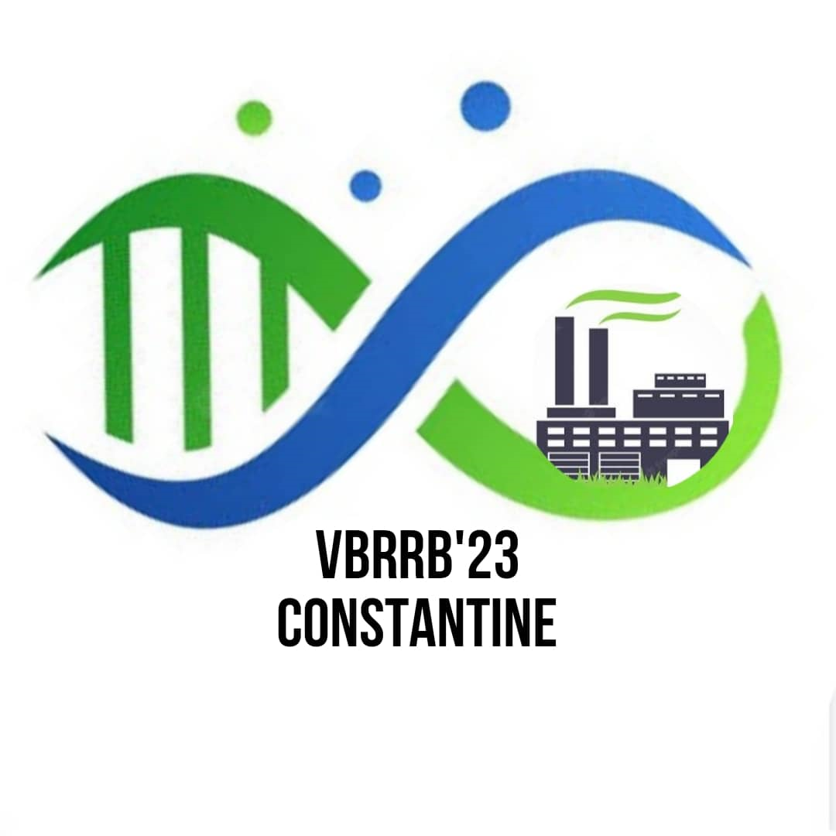
Title: TNR (14 pts) bold and centered
Author ¹* (Last name, First name), Author ², Author ³, …. TNR (12 pts) bold and centered
¹ Author’s affiliation 1, in TNR (10 pts) italic and centered
² Author’s affiliation 2, in TNR (10 pts) italic and centered
³ Author’s affiliation 3, in TNR (10 pts) italic and centered

Email* : xxxxx@xxxxxxxx

Subject description:Paragraph Paragraph Paragraph Paragraph Paragraph Paragraph Paragraph Paragraph Paragraph Paragraph Paragraph Paragraph Paragraph Paragraph Paragraph Paragraph Paragraph Paragraph Paragraph Paragraph Paragraph Paragraph Paragraph Paragraph.

Objectives: Paragraph Paragraph Paragraph Paragraph Paragraph Paragraph Paragraph Paragraph Paragraph Paragraph Paragraph Paragraph Paragraph Paragraph Paragraph Paragraph Paragraph Paragraph Paragraph Paragraph Paragraph Paragraph Paragraph Paragraph.

Methods: Paragraph Paragraph Paragraph Paragraph Paragraph Paragraph Paragraph Paragraph Paragraph Paragraph Paragraph Paragraph Paragraph Paragraph Paragraph Paragraph Paragraph Paragraph Paragraph Paragraph Paragraph Paragraph Paragraph Paragraph.

Results and discussion: Paragraph Paragraph Paragraph Paragraph Paragraph Paragraph Paragraph Paragraph Paragraph Paragraph Paragraph Paragraph Paragraph Paragraph Paragraph Paragraph Paragraph Paragraph Paragraph Paragraph Paragraph Paragraph Paragraph Paragraph.

Conclusion: Paragraph Paragraph Paragraph Paragraph Paragraph Paragraph Paragraph Paragraph Paragraph Paragraph Paragraph Paragraph Paragraph Paragraph Paragraph Paragraph Paragraph Paragraph Paragraph Paragraph Paragraph Paragraph Paragraph Paragraph.

Keywords: keyword 1, keyword 2, keyword 3, keyword 4, keyword 5, keyword 6 (6 keywords maximum).
(Word count should not exceed 300)

